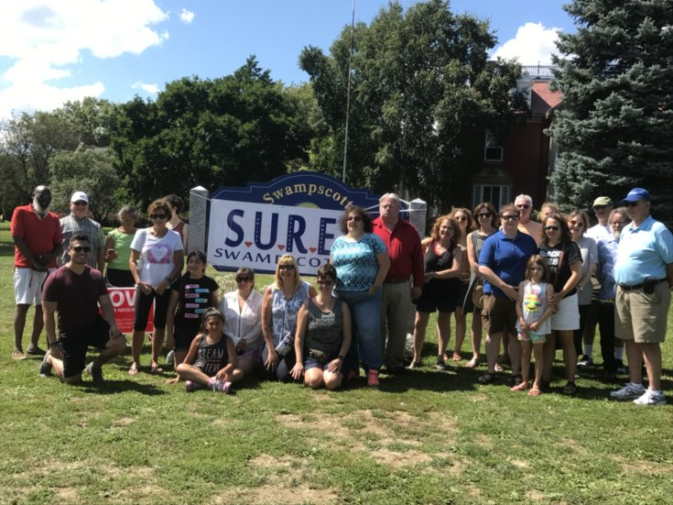  S.U.R.E. Gathering against hate, rally for Charlottesville, VA. August 2017  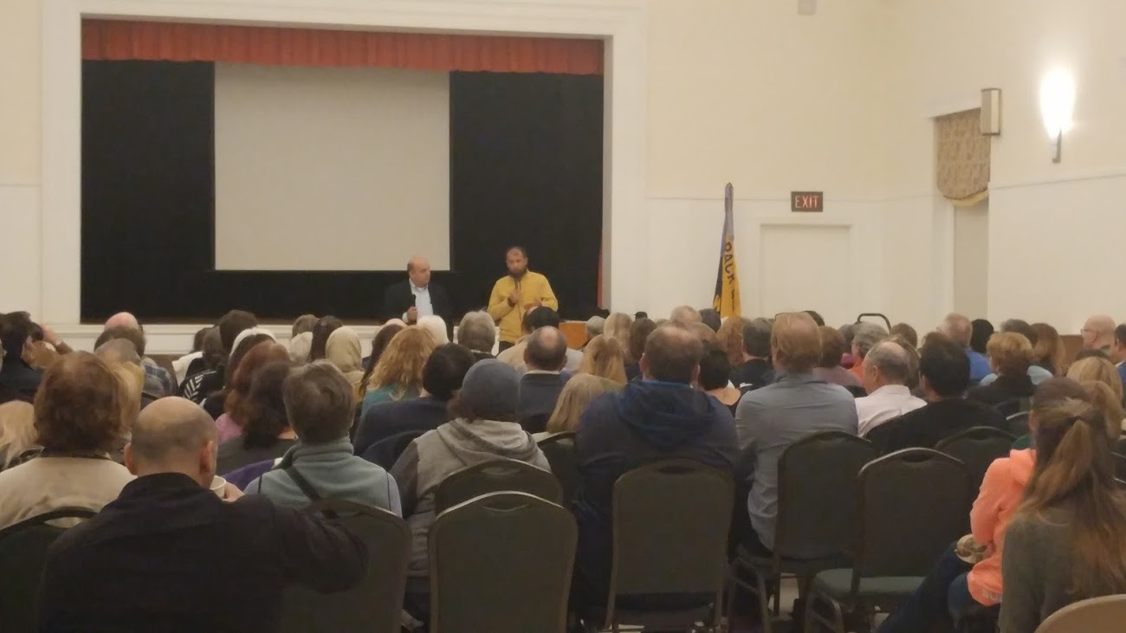  Raed Al Saleh, head of the White Helmets in Syria speaks to a large crowd. August 2016  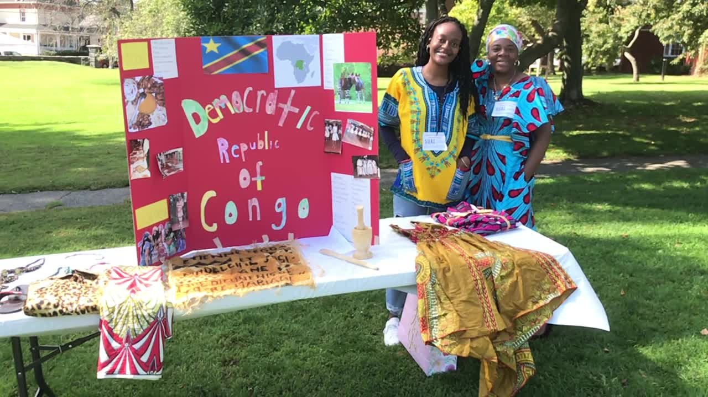  Democratic Republic of Congo represented at Diversity Festival September 2018 | Who We Are  About Us  S.U.R.E. diversity is a volunteer community group aimed at celebrating all aspects of human diversity.  Its purpose is to:  - Promote an understanding of Diversity  - Provide fun and educational opportunities to explore and experience Diversity  - Assist the community in developing cultural competency skills  - Engender a welcoming, nurturing, respectful and inclusive Swampscott community  - Be allies to our community who are facing prejudice of any kind  Our executive committee represents diversity of race, religion, gender, and ability.  Contact Us  Swampscott Unites, Respects, Embraces- SURE  Email: Surediversity@gmail.com  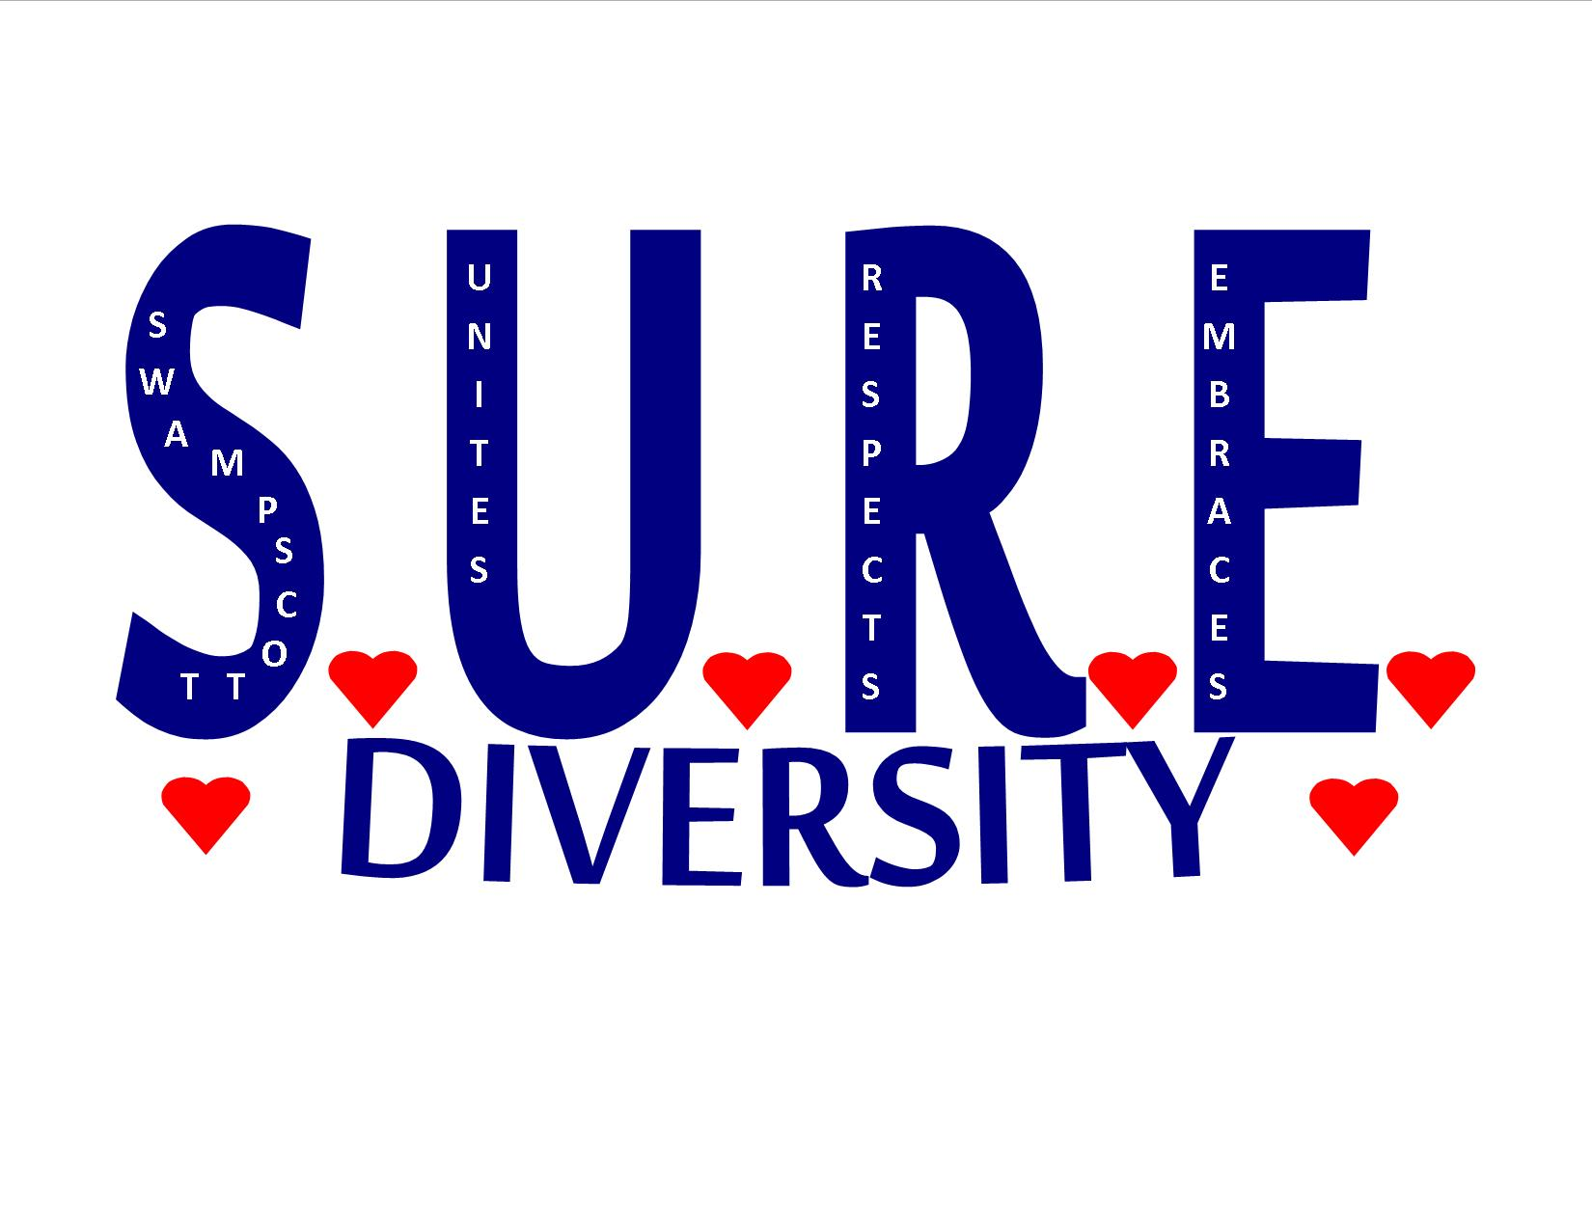 Swampscott, unites, respects and embraces diversity (S.U.R.E.) Swampscott, MA
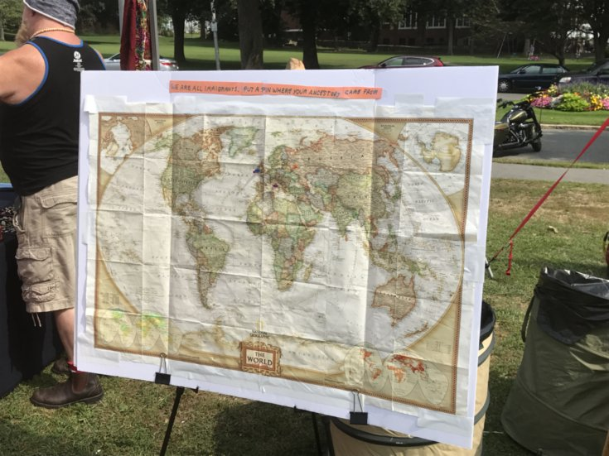  Map at Diversity Festival  EVENTS  Movies and Discussions  - Zootopia January 2017- Movie for kids that discusses diversity, after movie comments.  - Mirrors of Privilege: Making Whiteness Visible (Part I and Part II) November 2017 and January 2018-Movie and group discussions  Movies and Speaker  - White Helmets November 2016- Movie and head of White Helmets, Raed Al Saleh spoke to the community.  - An Introduction to Transgender Perspectives October 2018-nAGLY speaker and local family discussing issues.  - Intelligent Lives, a film by Dan Habib May 2019 Movie regarding intellectual disability bias and discussion groups.  Partnering with other Community Groups  - With SPUR, Rotary Club, Marblehead Charter, NuDay Syria March 2017-sent 2 containers to Syrian Refugees in Syria and Turkey  - With Town of Swampscott, FLOS, Boy Scouts, Swampscott Yacht Club August 2018-CommUNITY Bonfire Event  - With Local Clergy November 2017- Interfaith Thanksgiving Service  - With Reach Arts for Community Connections weekend-April 2019  Trainings  - Diversity Training with a Diversity Inclusion Expert May 2017-Members of S.U.R.E. and other community members  Community gatherings against Hate  - Rally against Hate, Marblehead, MA July 2017  - Gathering against hate, rally for Charlottesville, VA August 2017  Diversity Festivals (Hosted on Town Hall Lawn)  - 1st Annual Diversity Festival August 2016  - 2nd Annual Diversity Festival August 2017  - 3rd Annual Diversity Festival September 2018  - 4th Annual Diversity Festival September 2019 | 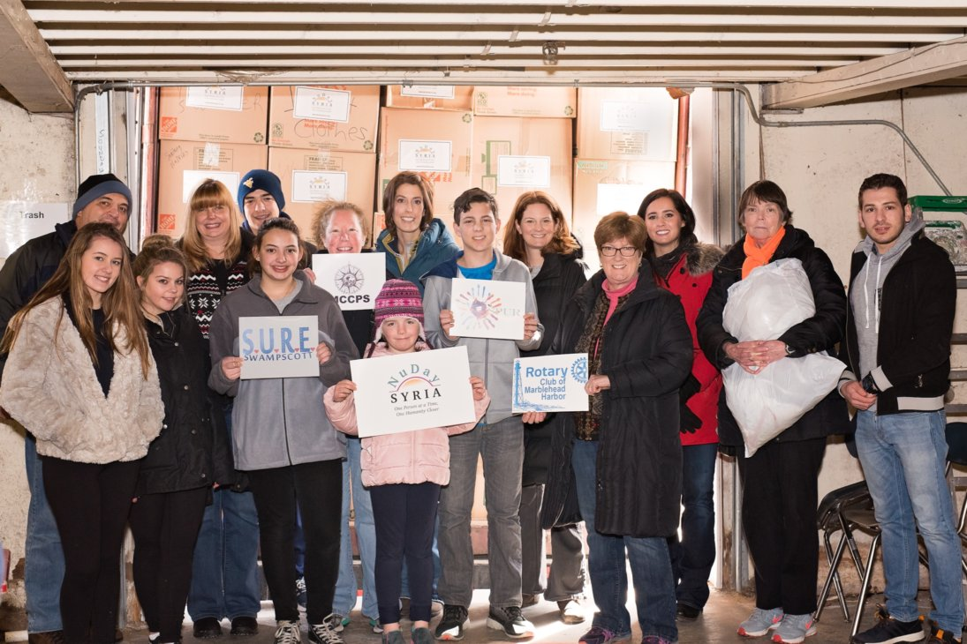  One of the two containers shipped to Turkey to help Syrian refugees in Turkey  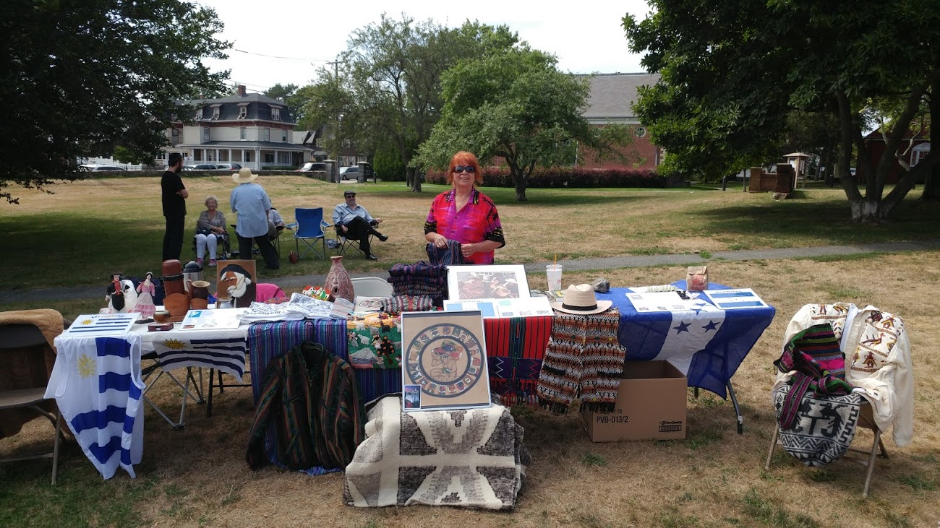  Guatemala, Honduras, and Uruguay represented at the Diversity Festival August 2017  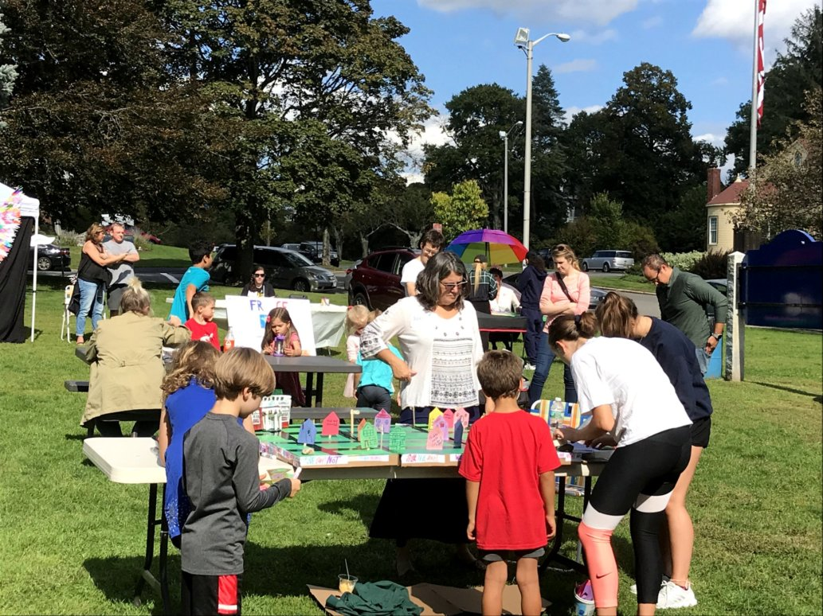  Community members with the Village of Kindness at Diversity Festival September 2018 | 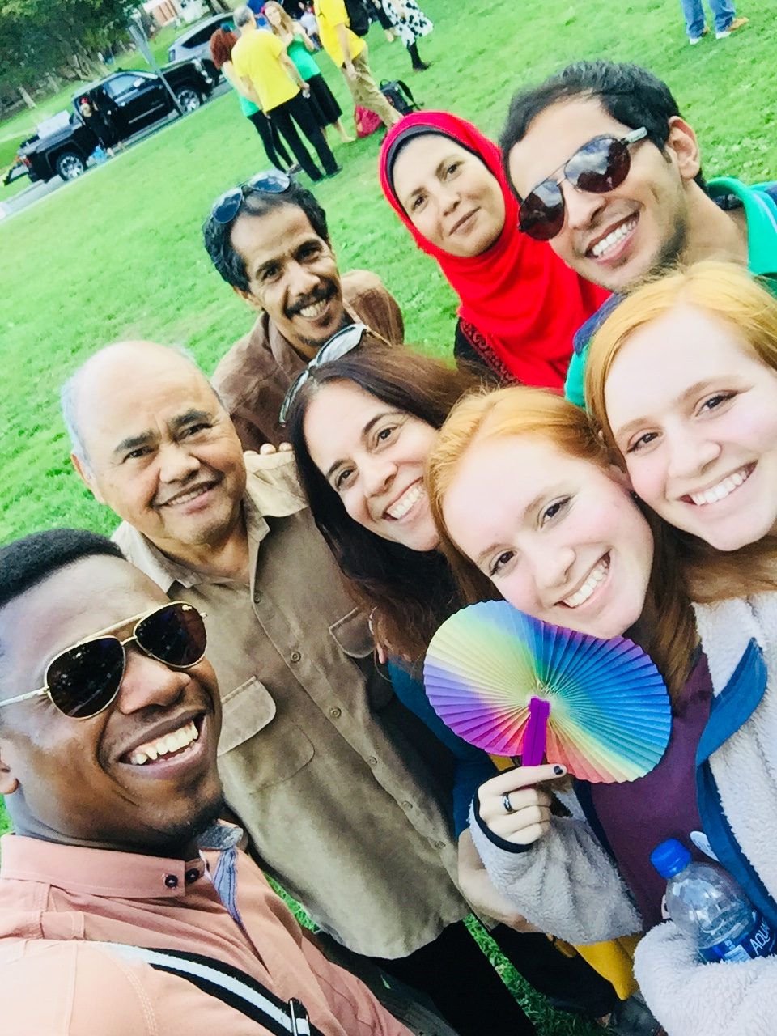  Local Residents and Friends showing their Diversity at the Diversity Festival, September 2018.  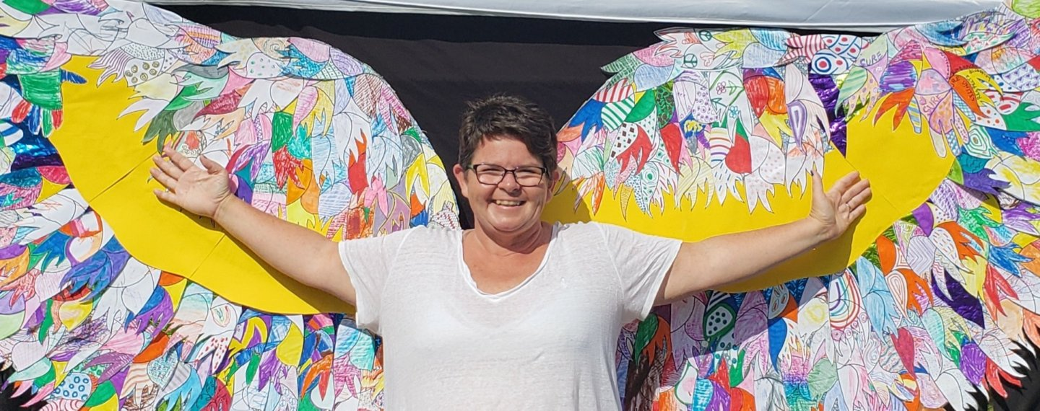  Diversity Festival 2018 with Wings created by residents  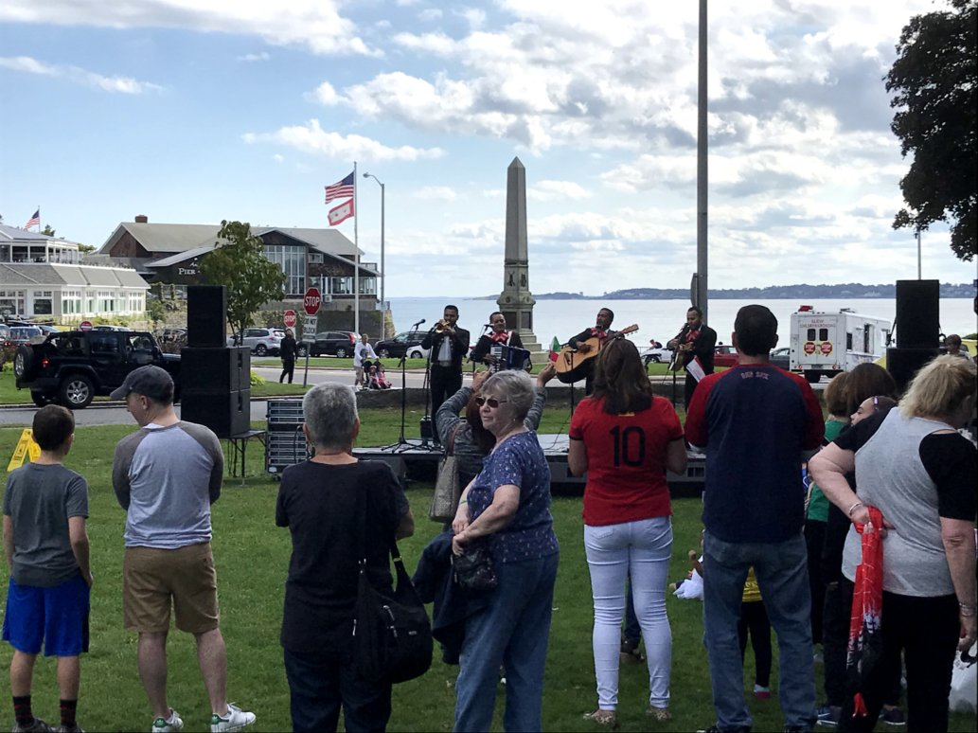  Entertainers on stage at Diversity Festival September 2018

